**RAJALAKSHMI ENGINEERING COLLEGE**

**RAJALAKSHMI NAGAR, THANDALAM – 602 105**



|  |
| --- |
| **CS23A34**  **USER INTERFACE AND DESIGN LAB** |
| **Laboratory Observation NoteBook** |

|  |
| --- |
| **Name :** L K SUDHARSHAN KRISHNAA  **Year/Branch/Section :** II/CSE/D  **Register No. :** 230701350  **Semester :** IV  **Academic Year:** 2024-25 |

**Ex. No. : 2 Date : 08.02.2025**

**Register No. : 230701350 Name : L K SUDHARSHAN KRISHNAA**



**Develop and compare CLI, GUI, and Voice User Interfaces (VUI) for the same task and assess user satisfaction using Python (Tkinter for GUI, Speech Recognition for VUI), Terminal**

**AIM:**

The aim is to develop and compare Command Line Interface (CLI), Graphical User Interface (GUI), and Voice User Interface (VUI) for the same task, and assess user satisfaction using Python (with Tkinter for GUI and Speech Recognition for VUI) and Terminal.

**PROCEDURE:**

i) CLI (Command Line Interface)

CLI implementation where users can add, view, and remove tasks using the terminal.

tasks=[]

def add_task(task):

tasks.append(task)

print(f"task'{task}'added.")

def view_tasks():

if tasks:

print("Your tasks:")

for idx, task in enumerate(tasks, 1):

print(f"{idx}.{task}")

else:

print("No tasks to show.")

def remove_task(task_number):

if 0<task_number<= len(tasks):

removed_task = tasks.pop(task_number - 1)

print(f"Task'{removed_task}'removed.")

else:

print("invalid task number.")

def main():

while True:

print("\nOptions: 1.Add Task 2.View Tasks 3.Remove Task 4.Exit")

choice = input("Enter your choice: ")

if choice == '1':

task = input("Enter task: ")

add_task(task)

elif choice == '2':

view_tasks()

elif choice == '3':

task_number = int(input("Enter task number to remove: "))

remove_task(task_number)

elif choice == '4':

print("Exiting...")

break

else:

print("Invalid choice. Please try again.")

if __name__ == "__main__":

main()

**Output :**

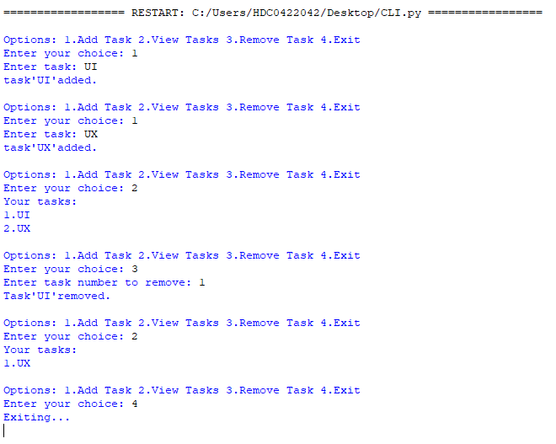

### ii) GUI (Graphical User Interface)

Tkinter to create a simple GUI for our To-Do List application:

import tkinter as tk

from tkinter import messagebox

tasks = []

def add_task():

task = task_entry.get()

if task:

tasks.append(task)

task_entry.delete(0, tk.END)

update_task_list()

else:

messagebox.showwarning("Warning", "Task cannot be empty")

def update_task_list():

task_list.delete(0, tk.END)

for task in tasks:

task_list.insert(tk.END, task)

def remove_task():

selected_task_index = task_list.curselection()

if selected_task_index:

task_list.delete(selected_task_index)

tasks.pop(selected_task_index[0])

app = tk.Tk()

app.title("To-Do List")

task_entry = tk.Entry(app, width=40)

task_entry.pack(pady=10)

add_button = tk.Button(app, text="Add Task", command=add_task)

add_button.pack(pady=5)

remove_button = tk.Button(app, text="Remove Task", command=remove_task)

remove_button.pack(pady=5)

task_list = tk.Listbox(app, width=40, height=10)

task_list.pack(pady=10)

app.mainloop()

**Output :**

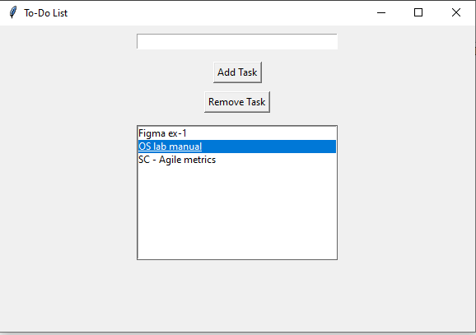

### iii) VUI (Voice User Interface)

speech_recognition library for voice input and the pyttsx3 library for text-to-speech output.

import speech_recognition as sr

import pyttsx3

tasks = []

recognizer = sr.Recognizer()

engine = pyttsx3.init()

def add_task(task):

tasks.append(task)

engine.say(f"Task {task} added")

engine.runAndWait()

def view_tasks():

if tasks:

engine.say("Your tasks are")

for task in tasks:

engine.say(task)

else:

engine.say("No tasks to show")

engine.runAndWait()

def remove_task(task_number):

if 0 < task_number <= len(tasks):

removed_task = tasks.pop(task_number - 1)

engine.say(f"Task {removed_task} removed")

else:

engine.say("Invalid task number")

engine.runAndWait()

def recognize_speech():

with sr.Microphone() as source:

print("Listening...")

audio = recognizer.listen(source)

try:

command = recognizer.recognize_google(audio)

return command

except sr.UnknownValueError:

engine.say("Sorry, I did not understand that")

engine.runAndWait()

return None

def main():

while True:

engine.say("Options: add task, view tasks, remove task, or exit")

engine.runAndWait()

command = recognize_speech()

if not command:

continue

if "add task" in command:

engine.say("What is the task?")

engine.runAndWait()

task = recognize_speech()

if task:

add_task(task)

elif "view tasks" in command:

view_tasks()

elif "remove task" in command:

engine.say("Which task number to remove?")

engine.runAndWait()

task_number = recognize_speech()

if task_number:

remove_task(int(task_number))

elif "exit" in command:

engine.say("Exiting...")

engine.runAndWait()

break

else:

engine.say("Invalid option. Please try again.")

engine.runAndWait()

if __name__ == "__main__":

main()

**Output :**

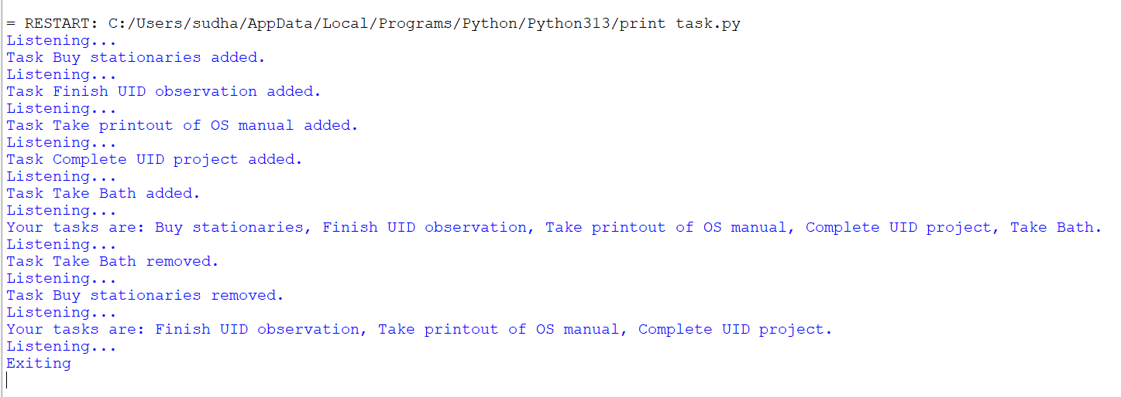

**Result :**

Hence the CLI, GUI, and Voice User Interfaces (VUI) for the same task using Python (Tkinter for GUI, Speech Recognition for VUI), Terminal has been developed and executed